Pre- activity: Animal Personalities

- How do specific animals fit people’s personalities? Fit the animal the personality traits:
Loyal |  | 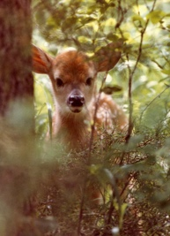
Brave |  | 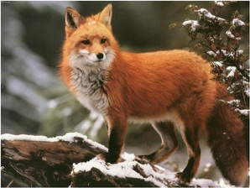
Hard working |  | 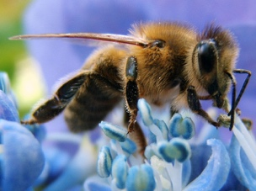
Smart |  | 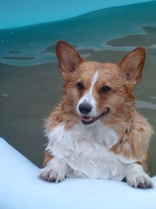
Sweet |  | 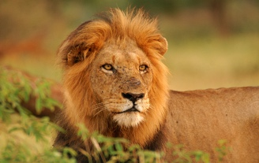
Smart |  | 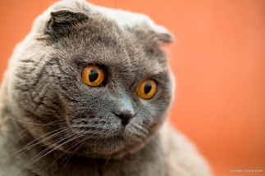
Cunning |  | 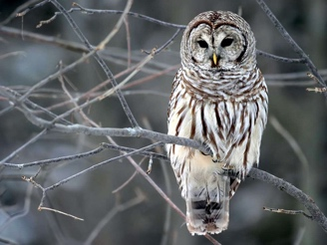

- What animal and its personality fit you? One of the list above? Or another?

While – activity: Online quiz
https://www.buzzfeed.com/elainawahl/what-should-be-your-new-favorite-animal?utm_term=.nrZjNy421#.oxZ8xzXdn

- Follow the link and make the online quiz.
Write down your outcome and the personality traits that fit.

Animal: Personality traits?

- Do you agree? Why?

After - activity: Survey the class

- Ask your classmates for their animals, and fill in the below table.

Name classmate | Animal? | Personality traits? | Do you agree?

